Introduction to Bayesian Data Analysis

Homework 2

104502518 資工4A 劉冠聲

1. Consider a normal probability density function that has mean of 10.0 and standard deviation of 0.20.
   1. What is the exact probability density at x=9.9?

**ANS: 1.760327**



* 1. Generate a random sample of 100,000 values from the normal distribution.



* 1. Compute the approximate probability density at x=9.9 by counting the proportion of sampled points that falls between x=9.8 and x=10.0, and then dividing by the width of the bin. Show your code and explain what it does. Is the result approximately the same as Part A? (It should be.)

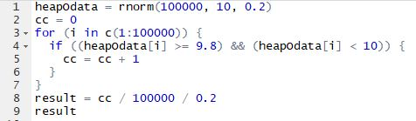

1. Suppose that if θ = 1, then y has a normal distribution with mean 1 and standard deviation σ, and if θ = 2, then y has a normal distribution with mean 2 and standard deviation σ. Also, suppose P(θ = 1) = 0.5 and P(θ = 2) = 0.5.
   1. For σ = 2, write the formula for the marginal probability density for y and sketch it.

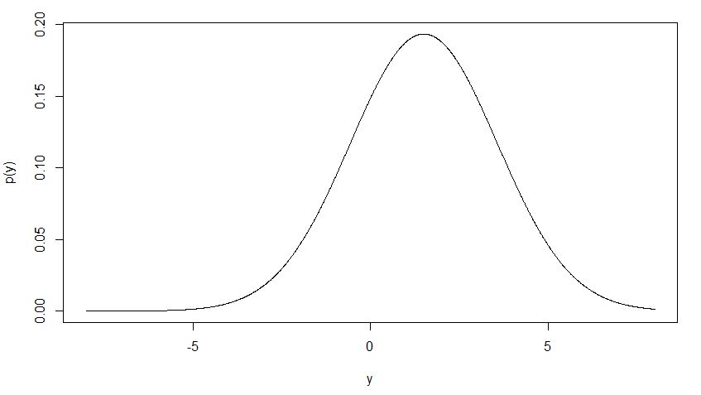

* 1. What is P(θ = 1|y = 1), again supposing σ = 2?
  2. Describe how the posterior density of θ changes in shape as σ is increased and as it is decreased.

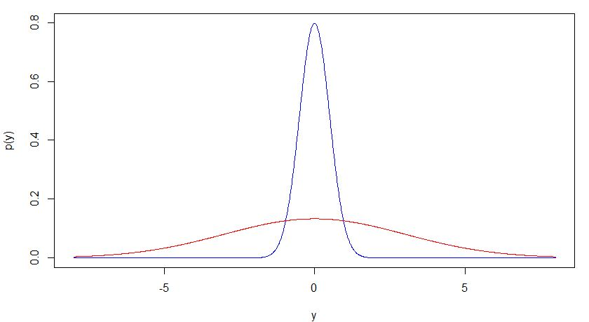

**由圖中可知**

**當σ越大，圖形就越寬範圍越大，資料較不密集**

**當σ越小，圖形就越窄範圍越小，資料較密集**

1. Approximately 1/125 of all births are fraternal twins and 1/300 of births are identical twins. Elvis Presley had a twin brother (who died at birth). What is the probability that Elvis was an identical twin? (You may approximate the probability of a boy or girl birth as 1.)